*Use the information in Chapter 49 (p.1069-1071) and Chapter 39 (p. 835-841) to answer the following questions. You may also want to watch the following Bozeman podcasts:* [*Mechanisms of Timing and Control*](http://www.bozemanscience.com/025-mechanisms-of-timing-and-control) *and* [*Behavior & Natural Selection*](http://www.bozemanscience.com/026-behavior-and-natural-selection)*.*

**Concept 49.2: The vertebrate brain is regionally specialized**

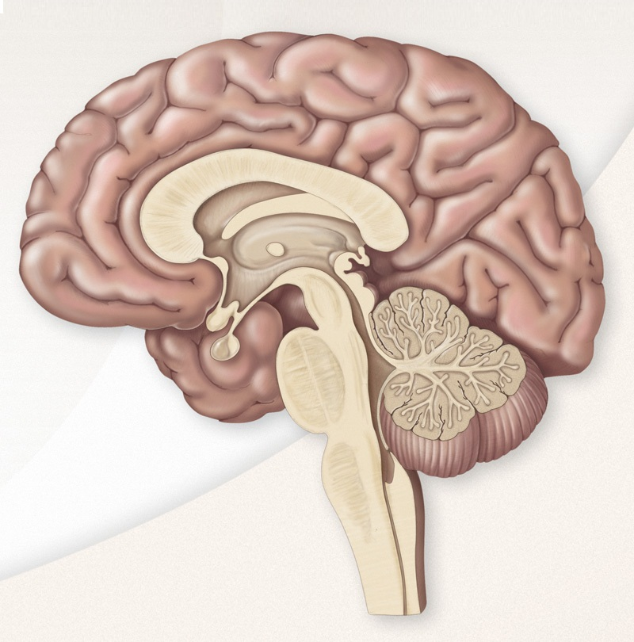Color code, label, and describe the function of the four major parts of the diencephalon:

* thalamus
* hypothalamus
* pineal gland
* pituitary gland

Describe the role of the suprachiasmatic nucleus (SCN) in circadian rhythm and describe the results of removing this region of the brain (Figure 49.12).

**Concept 39.9: Responses to light are critical for plant success**

*Complete the following chart to organize information about the light receptors in plants.*

|  |  |  |
| --- | --- | --- |
| **Light Receptor** | **Type of Light Detected** | **Plant Response(s)** |
| Blue-light receptors |  |  |
| Phytochromes |  |  |

Describe at least two pieces of evidence from the study of bean plants and *Arabidopsis* that support the following statement: *The molecular ‘gears’ of the biological clock are internally controlled, rather than a daily response to environmental stimuli.*

Describe the affect that light has on an organism’s biological clock.

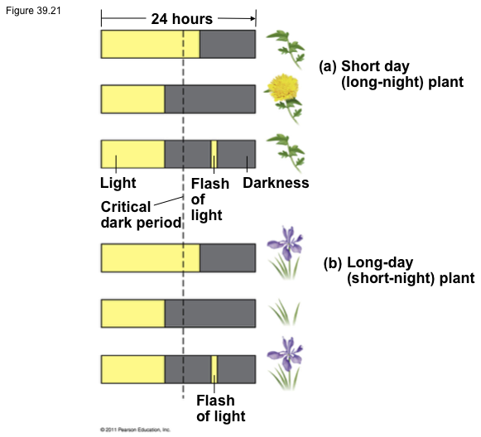Use the diagram to explain the difference in photoperiodism between short-day and long-day plants. Be sure to discuss the concept of “critical night length”.

Discuss how a day-neutral plant would compare to those pictured above.